**Obstacle Avoiding Robot**

**Submitted By-**

*Khushi Gupta, Neelu Devi*

**Introduction**

Obstacle Avoiding Robot is an Arduino based robot that uses Ultrasonic range finder sensors to avoid collisions.  The project proposes robotic vehicle that has an intelligence built in it such that it guides itself whenever an obstacle comes ahead of it.. An ultrasonic sensor is used to detect any obstacle ahead of it and sends a command to the Arduino.

**Components Required**

* Arduino UNO
* Ultrasonic Sensor HC-SR04
* L293d Motor Driver
* Servo Motor
* Mini Breadboard
* Jumper Wires
* Two dc motor

**Working**

When the robot is powered on, both the motors of the robot will run normally and the robot moves forward.

If the distance between the robot and the obstacle is less than 15cm, the Robot stops and scans in left and right directions for new distance using Servo Motor and Ultrasonic Sensor. If the distance towards the left side is more than that of the right side, the robot will prepare for a left turn. But first, it backs up a little bit and then activates the Left Wheel Motor in reversed in direction.

This process continues forever and the robot keeps on moving without hitting any obstacle.

**Obstacle Avoiding Robot**

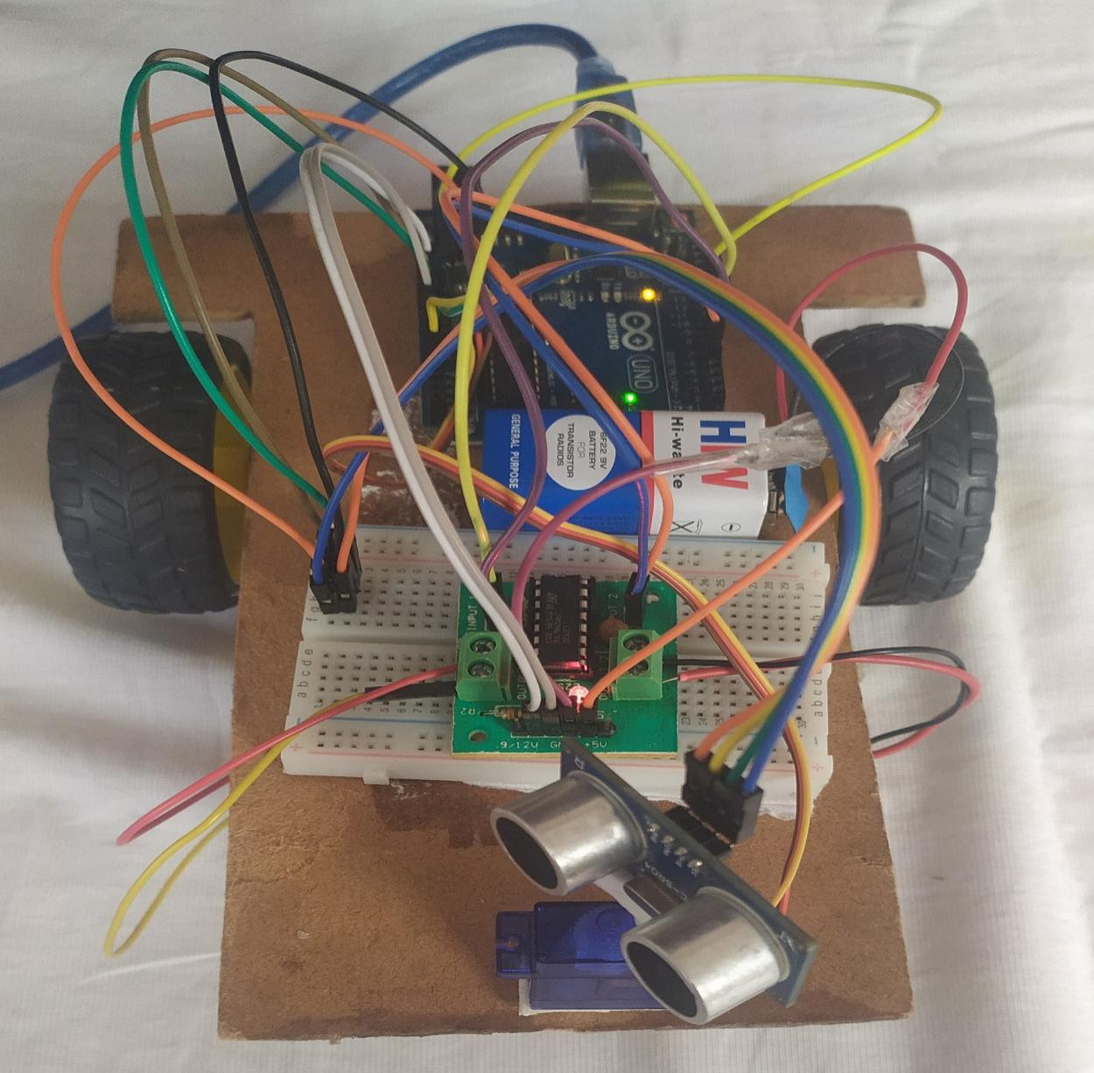

**Programming**

//our L298N control pins

const int LeftMotorForward = 7;

const int LeftMotorBackward = 6;

const int RightMotorForward = 4;

const int RightMotorBackward = 5;

//sensor pins

#define trig_pin A1 //analog input 1

#define echo_pin A2 //analog input 2

#define maximum_distance 200

boolean goesForward = false;

int distance = 100;

NewPing sonar(trig_pin, echo_pin, maximum_distance); //sensor function

Servo servo_motor; //our servo name

void setup(){

pinMode(RightMotorForward, OUTPUT);

pinMode(LeftMotorForward, OUTPUT);

pinMode(LeftMotorBackward, OUTPUT);

pinMode(RightMotorBackward, OUTPUT);

servo_motor.attach(10); //our servo pin

servo_motor.write(115);

delay(2000);

distance = readPing();

delay(100);

distance = readPing();

delay(100);

distance = readPing();

delay(100);

distance = readPing();

delay(100);

}

void loop(){

int distanceRight = 0;

int distanceLeft = 0;

delay(50);

if (distance <= 20){

moveStop();

delay(300);

moveBackward();

delay(400);

moveStop();

delay(300);

distanceRight = lookRight();

delay(300);

distanceLeft = lookLeft();

delay(300);

if (distance >= distanceLeft){

turnRight();

moveStop();

}

else{

turnLeft();

moveStop();

}

}

else{

moveForward();

}

distance = readPing();

}

int lookRight(){

servo_motor.write(50);

delay(500);

int distance = readPing();

delay(100);

servo_motor.write(115);

return distance;

}

int lookLeft(){

servo_motor.write(170);

delay(500);

int distance = readPing();

delay(100);

servo_motor.write(115);

return distance;

delay(100);

}

int readPing(){

delay(70);

int cm = sonar.ping_cm();

if (cm==0){

cm=250;

}

return cm;

}

void moveStop(){

digitalWrite(RightMotorForward, LOW);

digitalWrite(LeftMotorForward, LOW);

digitalWrite(RightMotorBackward, LOW);

digitalWrite(LeftMotorBackward, LOW);

}

void moveForward(){

if(!goesForward){

goesForward=true;

digitalWrite(LeftMotorForward, HIGH);

digitalWrite(RightMotorForward, HIGH);

digitalWrite(LeftMotorBackward, LOW);

digitalWrite(RightMotorBackward, LOW);

}

}

void moveBackward(){

goesForward=false;

digitalWrite(LeftMotorBackward, HIGH);

digitalWrite(RightMotorBackward, HIGH);

digitalWrite(LeftMotorForward, LOW);

digitalWrite(RightMotorForward, LOW);

}

void turnRight(){

digitalWrite(LeftMotorForward, HIGH);

digitalWrite(RightMotorBackward, HIGH);

digitalWrite(LeftMotorBackward, LOW);

digitalWrite(RightMotorForward, LOW);

delay(500);

digitalWrite(LeftMotorForward, HIGH);

digitalWrite(RightMotorForward, HIGH);

digitalWrite(LeftMotorBackward, LOW);

digitalWrite(RightMotorBackward, LOW);

}

void turnLeft(){

digitalWrite(LeftMotorBackward, HIGH);

digitalWrite(RightMotorForward, HIGH);

digitalWrite(LeftMotorForward, LOW);

digitalWrite(RightMotorBackward, LOW);

delay(500);

digitalWrite(LeftMotorForward, HIGH);

digitalWrite(RightMotorForward, HIGH);

digitalWrite(LeftMotorBackward, LOW);

digitalWrite(RightMotorBackward, LOW);

}

Applications

* Obstacle Avoiding Robot can be used as toys.
* Used for Army application.
* In mining Use.
* Obstacle detecting System for a Motor Vehicle
* They can be used for household works like automatic vacuum cleaning.